Compute Engine to create a two-tier application. The front-end VM runs a Node.js todo web app, and the back-end VM runs MongoDB.

Build a to-do app with MongoDB

CREATE A BACK-END VM

First, create the back-end VM that runs MongoDB. This server stores the to-do items.

Name the instance

Select the machine type

Select the machine type

Select "f1-micro". This will incur fewer charges. Learn more about pricing

Select the boot disk image

Open HTTP firewall port

Create the VM

While the back-end VM is spinning up, create the front-end VM that runs the Node.js todo application

Create the front-end VM

Click "Create Instance" to create the front-end VM

Name the instance

Select the machine type

Select the boot disk image

Open HTTP firewall port

Create the VM

Build a to-do app with MongoDB

INSTALL AND RUN THE BACK-END DATABASE

SSH into the VM

SSH into the VM

Next to your back-end VM, click SSH to open a terminal window in your browser

( for future note: you can graph this data and manage the Ubuntu system at <https://landscape.canonical.com/> Get cloud support with Ubuntu Advantage Cloud Guest:

<http://www.ubuntu.com/business/services/cloud> )

Install and run the database

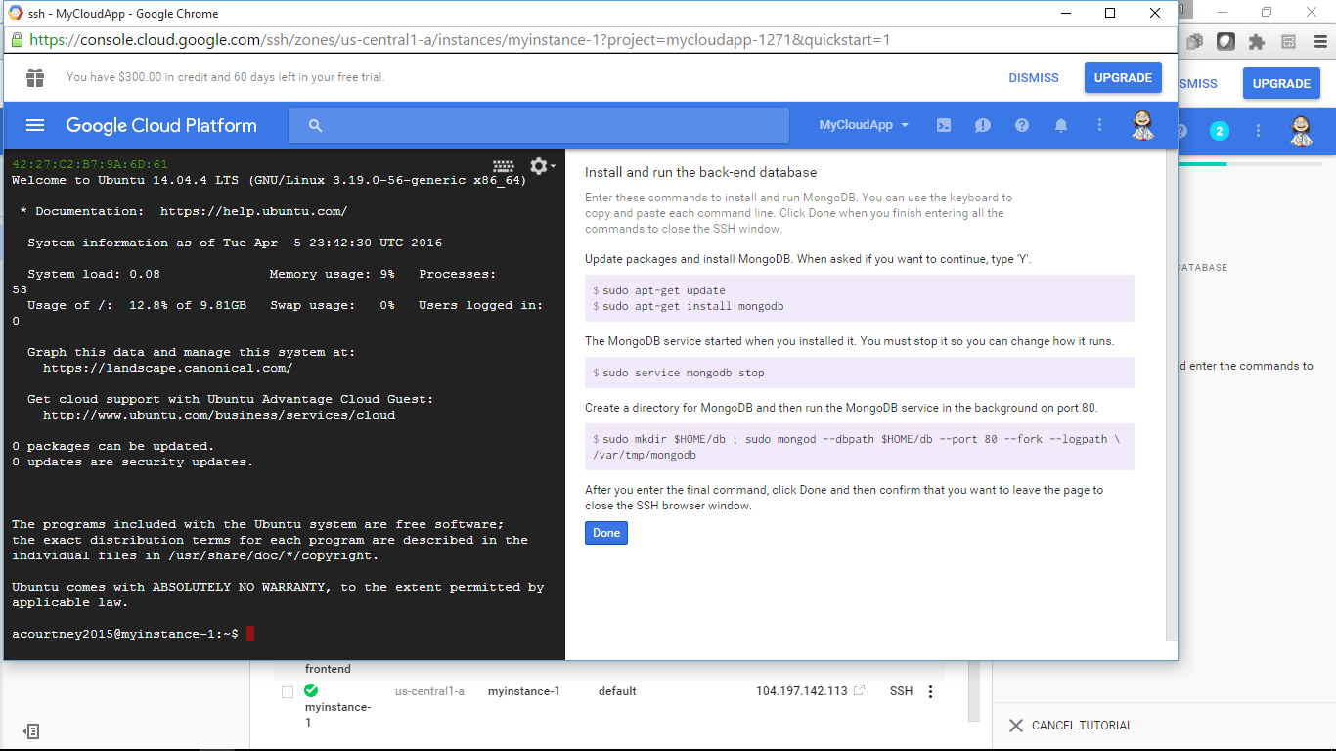

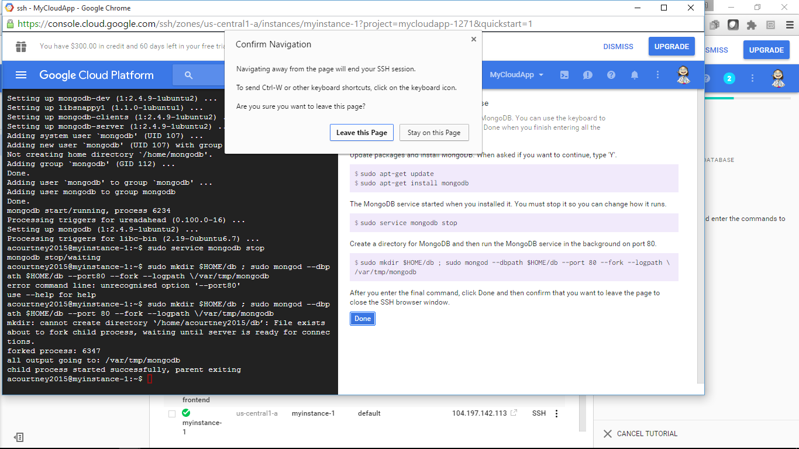

The MongoDB back-end server is running, so it is time to install the front-end web application

SSH into the VM

SSH into the VM

Next to your front-end VM, click SSH to open a terminal window in your browser

Install and run the web app on your front-end VM Follow the code

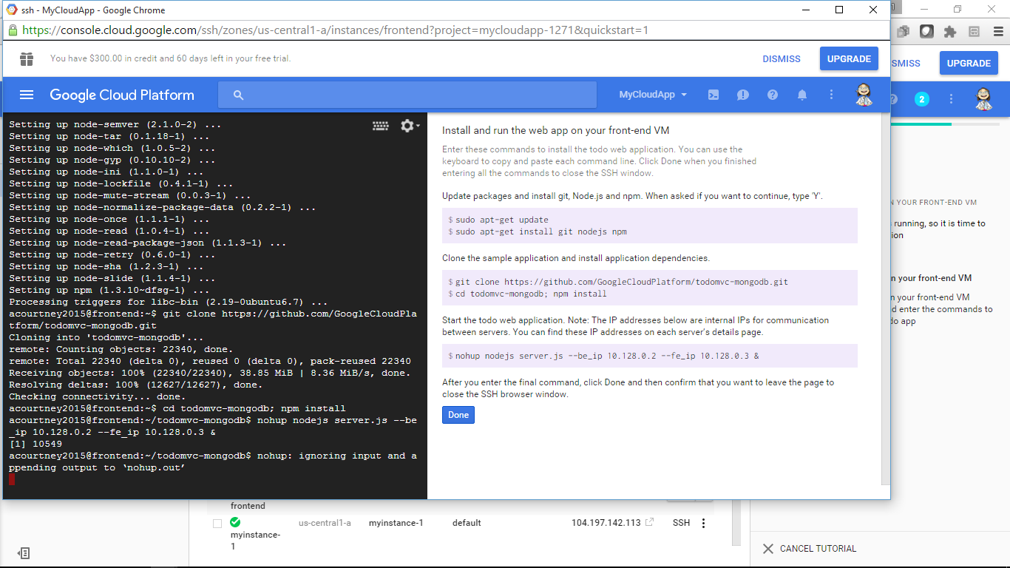

RUN THE SAMPLE TODO APP

Run the sample todo app

Click the following link to run the todo app in a new browser tab or window. The link uses the front-end server's external IP address to access the app.

<http://104.197.225.20:8080>

Finished product

